BARNO & ASHIQ’S PART

  - Governing balances, axial profiles, and operating-condition sensitivity for CO methanation.
Operating inputs, givens, and assumptions
Illustrative inlet (Figs. 2–4) | Dry feed CO:H$​_{2}$:N$​_{2}$ = 1:4:25 at $0.050 mol s^{−1}$: $F_{CO,0}=0.001667$, $F_{H_{2},0}=0.006667$, and $F_{N_{2},0}=0.041667 mol s^{−1}$; inlet CH$​_{4}$, H$​_{2}$O, and CO$​_{2}$ are zero. $T_{0}=T_{w}=623.15 K$ ($350 ^{∘}C$), $P_{0}=5.00 bar$.
Assumed bed and transport | $D_{t}=0.0254 m$, $L=0.3048 m$, and $ρ_{B}=750 kg m_{bed}^{−3}$ give $W_{tot}=0.1158 kg$ (calculated); $ε_{b}=0.40$, $D_{p}=3 mm$, $μ=2.5×{10}^{−5} Pa s$, and $U=10 W m^{−2} K^{−1}$. Pressure drop uses Ergun; wall heat exchange is enabled and fresh-catalyst activity is $a=1$.
Model and numerical assumptions | Figs. 2–3 use reduced M4 (CO methanation/WGS); Fig. 4 uses Full M4, including direct CO$​_{2}$ methanation. Heat capacities are constant (CO/H$​_{2}$/CH$​_{4}$/H$​_{2}$O/CO$​_{2}$/N$​_{2}$: 30.3/29.3/52.0/36.5/46.5/30.1 $J mol^{−1} K^{−1}$) and reaction heats are fixed at $−ΔH_{2}=206$ and $−ΔH_{W}=41 kJ mol^{−1}$. The stiff system uses Radau and 401 output points.
Group-14 reported inputs | Appendix B, Table 3: CO/H$​_{2}$/N$​_{2}$ = 0.320/0.399/0.799 $mol h^{−1}$; catalyst = 3.00 g, reaction temperature = $350 ^{∘}C$, and pressure = 760 mmHg (about 1.013 bar). These source-reported conditions are separate from the 5-bar illustrative run above.
Other figure cases | Part I (Figs. 1–4) contains the 1-bar three-model Experiment 1 comparison, two illustrative base-case profiles, and the assumed Full M4 species profile. Part II (Figs. 5–10) contains the Full M4 temperature-pressure, ratio/space-time, and feed-flow sensitivities, including the isolated N$​_{2}$ sweep. Part III (Fig. 11 and Table 1) contains the four-factor Full M4 grid-search optimization. The 1-bar comparison and sensitivity cases are below the Full M4 5–15 bar fitted pressure interval; model-specific domain limits are stated with the verification figure.

Model basis
The bed is treated as a steady, one-dimensional plug-flow reactor. The reduced network retains CO methanation and water-gas shift (WGS):
$$\begin{aligned}CO+3H_{2}&→CH_{4}+H_{2}O&&(r_{2}), \\ CO+H_{2}O&→CO_{2}+H_{2}&&(r_{W}).\end{aligned}$$
At each position, the reduced M4 kinetics give net rates $r_{2}$ and $r_{W}$ from local temperature and partial pressures $p_{i}=y_{i}P$. Rates are in $mol kg_{cat}^{−1} s^{−1}$, flows $F_{i}$ in $mol s^{−1}$, and $a$ is catalyst activity. Integration uses catalyst mass $W$. For uniform loading $ρ_{B}$ in a tube of cross-section $A_{c}=πD_{t}^{2}/4$,
$$W=ρ_{B}A_{c}z, z=\frac{W}{ρ_{B}A_{c}}, W_{tot}=ρ_{B}A_{c}L.$$
A steady mole balance over a catalyst slice $dW$ gives dFi/dW=aj​νijrj, where $a$ is catalyst activity. Written for the modeled species:
$$\begin{aligned}\frac{dF_{CO}}{dW}&=−a(r_{2}+r_{W}),&\frac{dF_{H_{2}}}{dW}&=a(−3r_{2}+r_{W}), \\ \frac{dF_{CH_{4}}}{dW}&=ar_{2},&\frac{dF_{H_{2}O}}{dW}&=a(r_{2}−r_{W}), \\ \frac{dF_{CO_{2}}}{dW}&=ar_{W},&\frac{dF_{N_{2}}}{dW}&=0.\end{aligned}$$

Temperature from the energy balance
For a differential slice, reaction heat raises the gas sensible enthalpy; heat transfer to the wall removes heat when the gas is hotter than the wall. Thus
i​FiCp,idTdW=ar2(−ΔH2)+rW(−ΔHW)−UawρB(T−Tw).
Dividing by the gas heat-capacity flow gives the temperature equation integrated by the solver:
dTdW=ar2(−ΔH2)+rW(−ΔHW)−UawρB(T−Tw)i​FiCp,i
Here $a_{w}=4/D_{t}$ is the cylindrical heat-transfer area per bed volume. The formulation uses exothermic heats $−ΔH_{2}=206$ and $−ΔH_{W}=41 kJ mol^{−1}$. The current implementation uses constant heat capacities and these constant reaction enthalpies.

Pressure from the Ergun equation
The Ergun pressure gradient combines viscous resistance (first term) and inertial resistance (second term):
$$\frac{dP}{dz}=−\left[\frac{150μ(1−ε_{b})^{2}u_{s}}{D_{p}^{2}ε_{b}^{3}}+\frac{1.75ρ_{g}(1−ε_{b})u_{s}^{2}}{D_{p}ε_{b}^{3}}\right].$$
The reacting-gas properties are recalculated locally:
us=FtotRTPAc, ρg=PMRT, M=i​yiMi, yi=FiFtot.
Since $dz/dW=1/(ρ_{B}A_{c})$, the pressure equation in the solver’s catalyst-mass coordinate is
$$\boxed{\frac{dP}{dW}=−\frac{1}{ρ_{B}A_{c}}\left[\frac{150μ(1−ε_{b})^{2}u_{s}}{D_{p}^{2}ε_{b}^{3}}+\frac{1.75ρ_{g}(1−ε_{b})u_{s}^{2}}{D_{p}ε_{b}^{3}}\right]}$$
Pressure is integrated in Pa; the kinetic partial pressures are evaluated in bar. The pressure loss is coupled to reaction because the local flow, composition, temperature, and density change down the bed.

Integrated solution and plotting
The numerical problem is the coupled initial-value system
$$\frac{dy}{dW}=f(y), y(W)={\left[\begin{matrix}F(W)^{T} & T(W) & P(W)\end{matrix}\right]}^{T}, y(0)={\left[\begin{matrix}F_{0}^{T} & T_{0} & P_{0}\end{matrix}\right]}^{T}, 0≤W≤W_{tot}.$$
The code integrates this system with the stiff Radau method and samples the solution at 401 evenly spaced catalyst-mass locations. The plotted coordinates are $z_{j}=W_{j}/(ρ_{B}A_{c})$, $T_{j}=T(W_{j})$, and $P_{j,bar}=P(W_{j})/{10}^{5}$. CO conversion is calculated as
$$X_{CO}(W)=1−\frac{F_{CO}(W)}{F_{CO,0}}.$$
Differentiating this definition and substituting the CO balance gives
$$\frac{dX_{CO}}{dW}=\frac{a(r_{2}+r_{W})}{F_{CO,0}}.$$
Therefore, the figures show samples of the integrated profiles, not a separate closed-form solution for $T(z)$ or $P(z)$.

Kinetic rate-law audit
The verification implementations were checked against the printed kinetic equations and their published parameter bases. All partial pressures are evaluated from local mole fractions and total pressure; the literature-model integrators convert reported rates to the common catalyst-mass coordinate. The comparison remains a no-fit transferability check because the catalysts and, for Quindimil, the inlet reaction family differ from Experiment 1.
Full M4. The implementation follows Celoria et al., Eqs. (19)–(21), with the common denominator
$$D_{M4}=1+\sqrt{K_{H_{2}}p_{H_{2}}}+K_{CO}p_{CO}+K_{C}\frac{p_{CH_{4}}}{p_{H_{2}}^{2}}+K_{CH_{4}}p_{CH_{4}}.$$
Expanding the paper’s equilibrium-driving-force forms gives the rates used in code:
$$\begin{aligned}r_{1}&=\frac{k_{1}}{D_{M4}^{2}}\left(\frac{p_{CO_{2}}p_{H_{2}}^{3/2}}{p_{H_{2}O}}−\frac{p_{CH_{4}}p_{H_{2}O}}{K_{eq,1}p_{H_{2}}^{5/2}}\right), \\ r_{2}&=\frac{k_{2}}{D_{M4}^{2}}\left(p_{CO}\sqrt{p_{H_{2}}}−\frac{p_{CH_{4}}p_{H_{2}O}}{K_{eq,2}p_{H_{2}}^{5/2}}\right), \\ r_{3}^{RWGS}&=\frac{k_{3}}{D_{M4}^{2}}\left(p_{CO_{2}}\sqrt{p_{H_{2}}}−\frac{p_{CO}p_{H_{2}O}}{K_{eq,3}\sqrt{p_{H_{2}}}}\right).\end{aligned}$$
Here $r_{1}$ and $r_{2}$ are the methanation rates and $r_{3}^{RWGS}$ is the paper’s reverse water-gas-shift rate. The public reactor rates use forward WGS, so its signed rate is $r_{W}=−r_{RWGS}$. Kinetic and adsorption temperature shifts use the paper’s Arrhenius and van’t Hoff forms, respectively. Source: Celoria et al. (2025).
Kopyscinski. Equations (25)–(26) in the published corrigendum are used, including the corrected $\sqrt{p_{CO}}$ adsorption factor:
$$D_{K}=1+K_{C}\sqrt{p_{CO}}+K_{OH}\frac{p_{H_{2}O}}{\sqrt{p_{H_{2}}}}, r_{CH_{4}}=\frac{k_{1}K_{C}\sqrt{p_{CO}p_{H_{2}}}}{D_{K}^{2}}, r_{W}=\frac{k_{2}\left(K_{α}p_{CO}p_{H_{2}O}−p_{CO_{2}}p_{H_{2}}/K_{eq}\right)}{\sqrt{p_{H_{2}}}D_{K}^{2}}.$$
The paper’s second rate is positive in the forward WGS direction; the verification integrator converts it to the internal RWGS stoichiometric sign. The Arrhenius and adsorption-constant correlations are the published ones, with pressure in bar and rates in mol kg$​_{cat}^{−1}$ s$​^{−1}$. Source: Kopyscinski et al. corrigendum.
Quindimil. The implemented shared denominator and expanded rates are
$$D_{Q}^{impl}=1+K_{HCOO}p_{CO_{2}}\sqrt{p_{H_{2}}}+K_{OH}\frac{p_{H_{2}O}}{\sqrt{p_{H_{2}}}}+K_{CO}p_{CO}, \begin{aligned}r_{RWGS}&=\frac{k_{4}}{(D_{Q}^{impl})^{2}}\left(p_{CO_{2}}\sqrt{p_{H_{2}}}−\frac{p_{CO}p_{H_{2}O}}{K_{eq,RWGS}\sqrt{p_{H_{2}}}}\right), \\ r_{CH_{4}}&=\frac{k_{6}}{(D_{Q}^{impl})^{2}}\left(p_{CO}\sqrt{p_{H_{2}}}−\frac{p_{CH_{4}}p_{H_{2}O}}{K_{eq,COmeth}p_{H_{2}}^{5/2}}\right).\end{aligned}$$
The reversible driving forces are algebraically equivalent to the paper’s RWGS and CO-methanation forms; the gas-phase CO net formation is $r_{CO,net}=r_{RWGS}−r_{CH_{4}}$. Table 4 values are shifted with the paper’s activation-energy/adsorption-enthalpy correlations; pressures are converted from bar to atm and rates from mol g$​_{cat}^{−1}$ h$​^{−1}$ to mol kg$​_{cat}^{−1}$ s$​^{−1}$. One qualification matters: Appendix A, Eq. (A3.15), contains an additional standalone $\sqrt{K_{H_{2}}p_{H_{2}}}$ term in the shared denominator, but Table 4 reports only the composite $K_{HCOO}=K_{CO_{2}}\sqrt{K_{H_{2}}}$ and does not tabulate an independent $K_{H_{2}}$. The current code retains the reported composite term and omits that standalone contribution. Therefore this is a reduced/lumped reading of the published model, not an exact reproduction of the full printed denominator. In addition, the model was fitted to CO$​_{2}$/H$​_{2}$ experiments, so applying it to the CO/H$​_{2}$ inlet is a feed-scope extrapolation. Source: Quindimil et al. (2022).
The signs are consistent once directions are made explicit: the M4 kinetics report RWGS and the reactor uses WGS ($r_{W}=−r_{RWGS}$); Kopyscinski’s second rate is forward WGS and is negated for the reactor’s RWGS stoichiometric column; Quindimil’s pair is represented as RWGS plus CO methanation. The M4 equilibrium constants in this code use the documented constant-$ΔH$ thermodynamic closure, rather than claiming a verbatim reproduction of an unreported paper-specific numerical equilibrium correlation.
Plotted demonstration case. $D_{t}=0.0254 m$ (1.00 in), $L=0.3048 m$ (12.00 in), $ρ_{B}=750 kg m^{−3}$, $ε_{b}=0.40$, $D_{p}=3 mm$, $μ=2.5×{10}^{−5} Pa s$, $U=10 W m^{−2} K^{−1}$; $T_{0}=T_{w}=623.15 K$, $P_{0}=5 bar$, and feed ratio CO:H$​_{2}$:N$​_{2}$=1:4:25 at $0.05 mol s^{−1}$. Several geometry, feed, transport, and heat-transfer inputs remain assumed; this run is illustrative, not experimental validation.
PART I

Verification and reactor profiles
A common-basis comparison with Experiment 1, followed by the illustrative base-case conversion and bed profiles.

Experiment 1 CO-conversion comparison
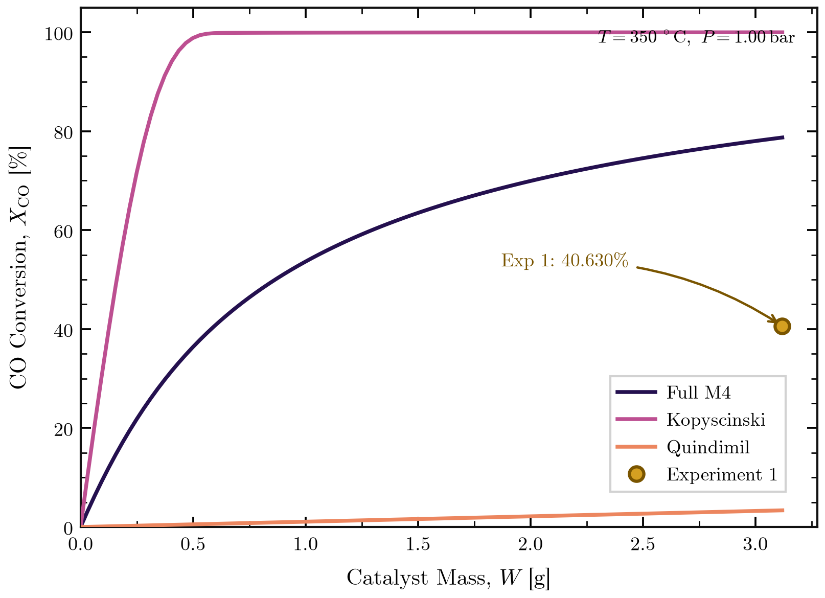
Figure 1. No-fit predictions from Full M4, Kopyscinski, and the reduced/lumped Quindimil implementation at the Experiment 1 basis (350 $​^{∘}$C, 1.00 bar, 3.12 g catalyst, isothermal, constant pressure).
The measured outlet conversion is 40.63%; predictions are 78.72% (Full M4), 99.985% (Kopyscinski), and 3.37% (Quindimil). Only Kopyscinski is evaluated within its cited 1–2 bar pressure interval. Full M4 is below its 5–15 bar fit range; Quindimil is below its 2–6 bar range and its parameters were fitted to CO$​_{2}$/H$​_{2}$, not this CO/H$​_{2}$ feed. Catalyst formulations also differ. Read this as a no-fit transferability comparison, not independent validation of all three models. The Quindimil denominator is the reduced/lumped form described in the kinetic audit above.

CO conversion along the catalyst bed
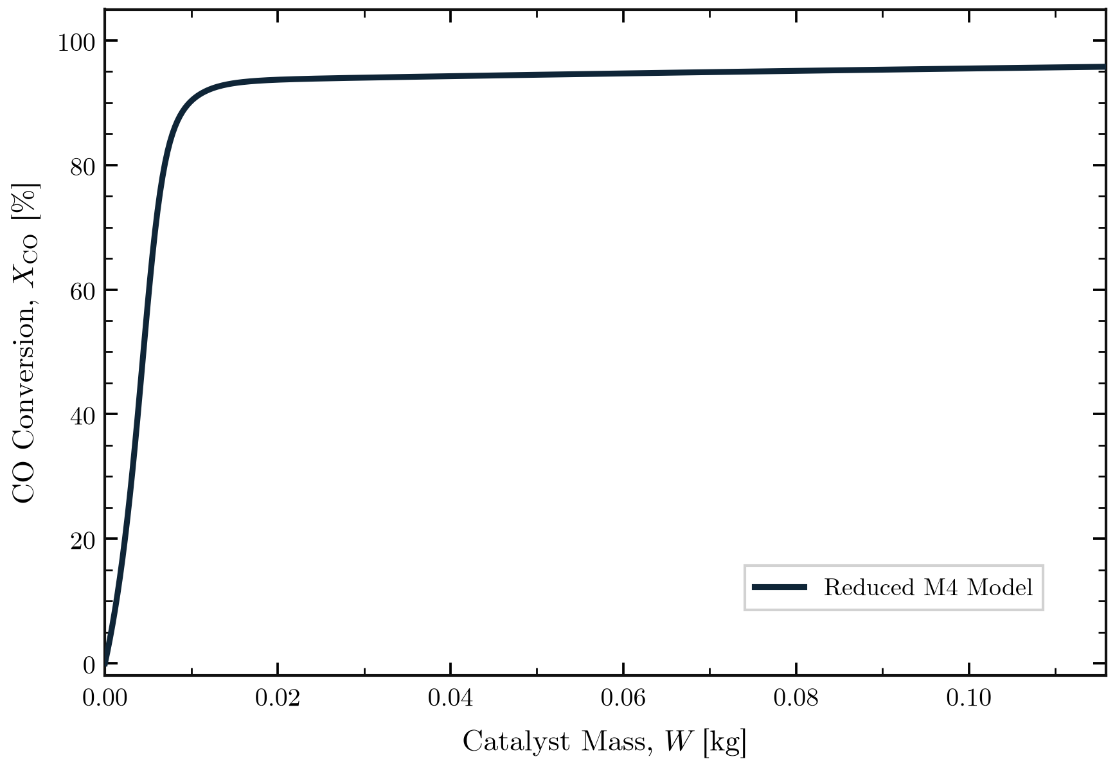
Figure 2. Reduced M4 model prediction of CO conversion versus catalyst mass for the demonstration case.
The calculated outlet conversion is $95.78\%$ for this assumed configuration. This curve is a model demonstration, not an experimental fit or validation result.

Temperature and pressure along the bed
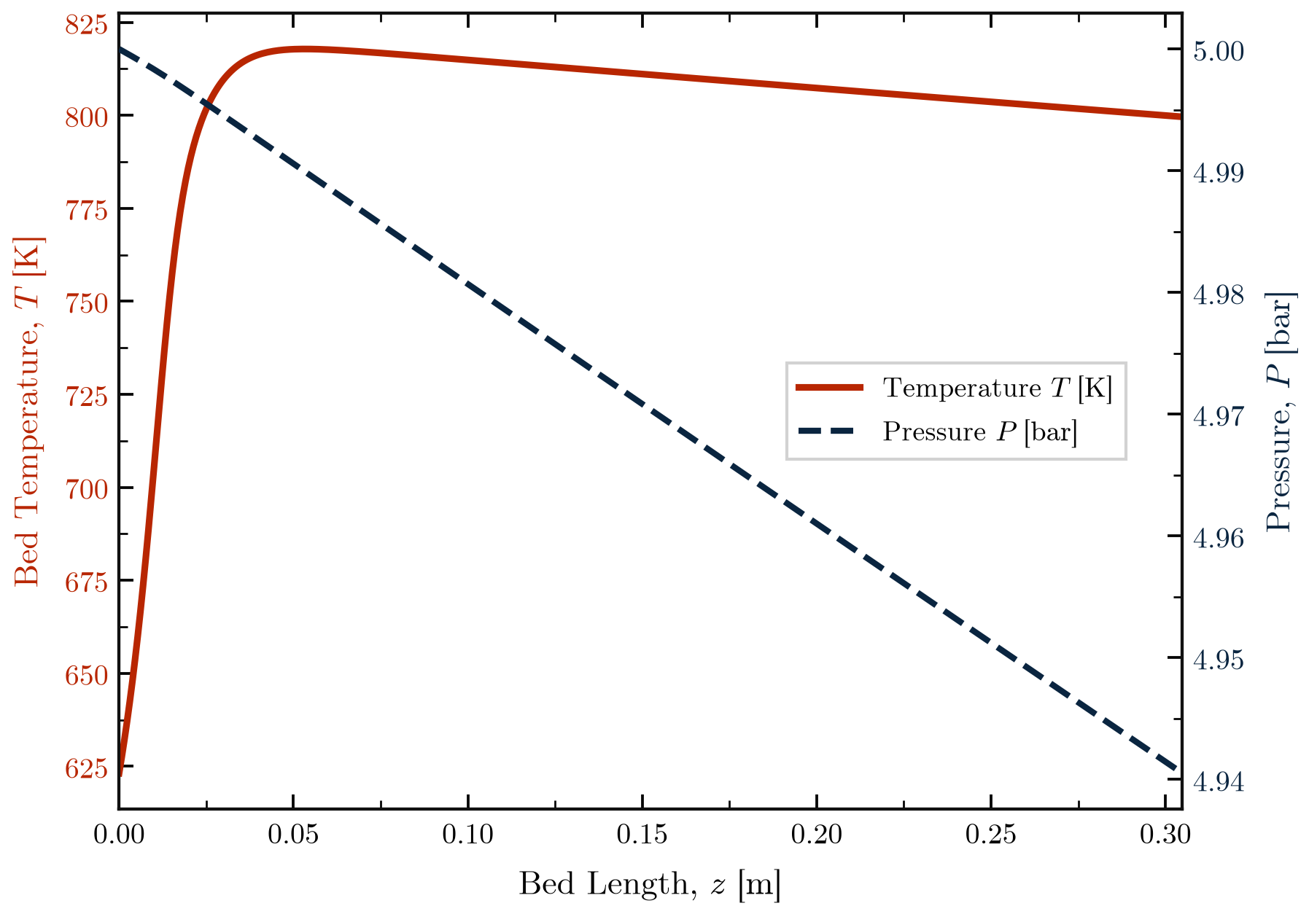
Figure 3. Integrated temperature and Ergun pressure profiles versus bed length.
The sampled temperature peaks at $817.8 K$ near $z=0.0533 m$ and is $799.6 K$ at the outlet. Pressure falls from $5.0000$ to $4.9405 bar$ (about $5.95 kPa$). The plotted pressure axis is tightly auto-scaled, so the visible line exaggerates this relative drop.

Species concentrations along the bed
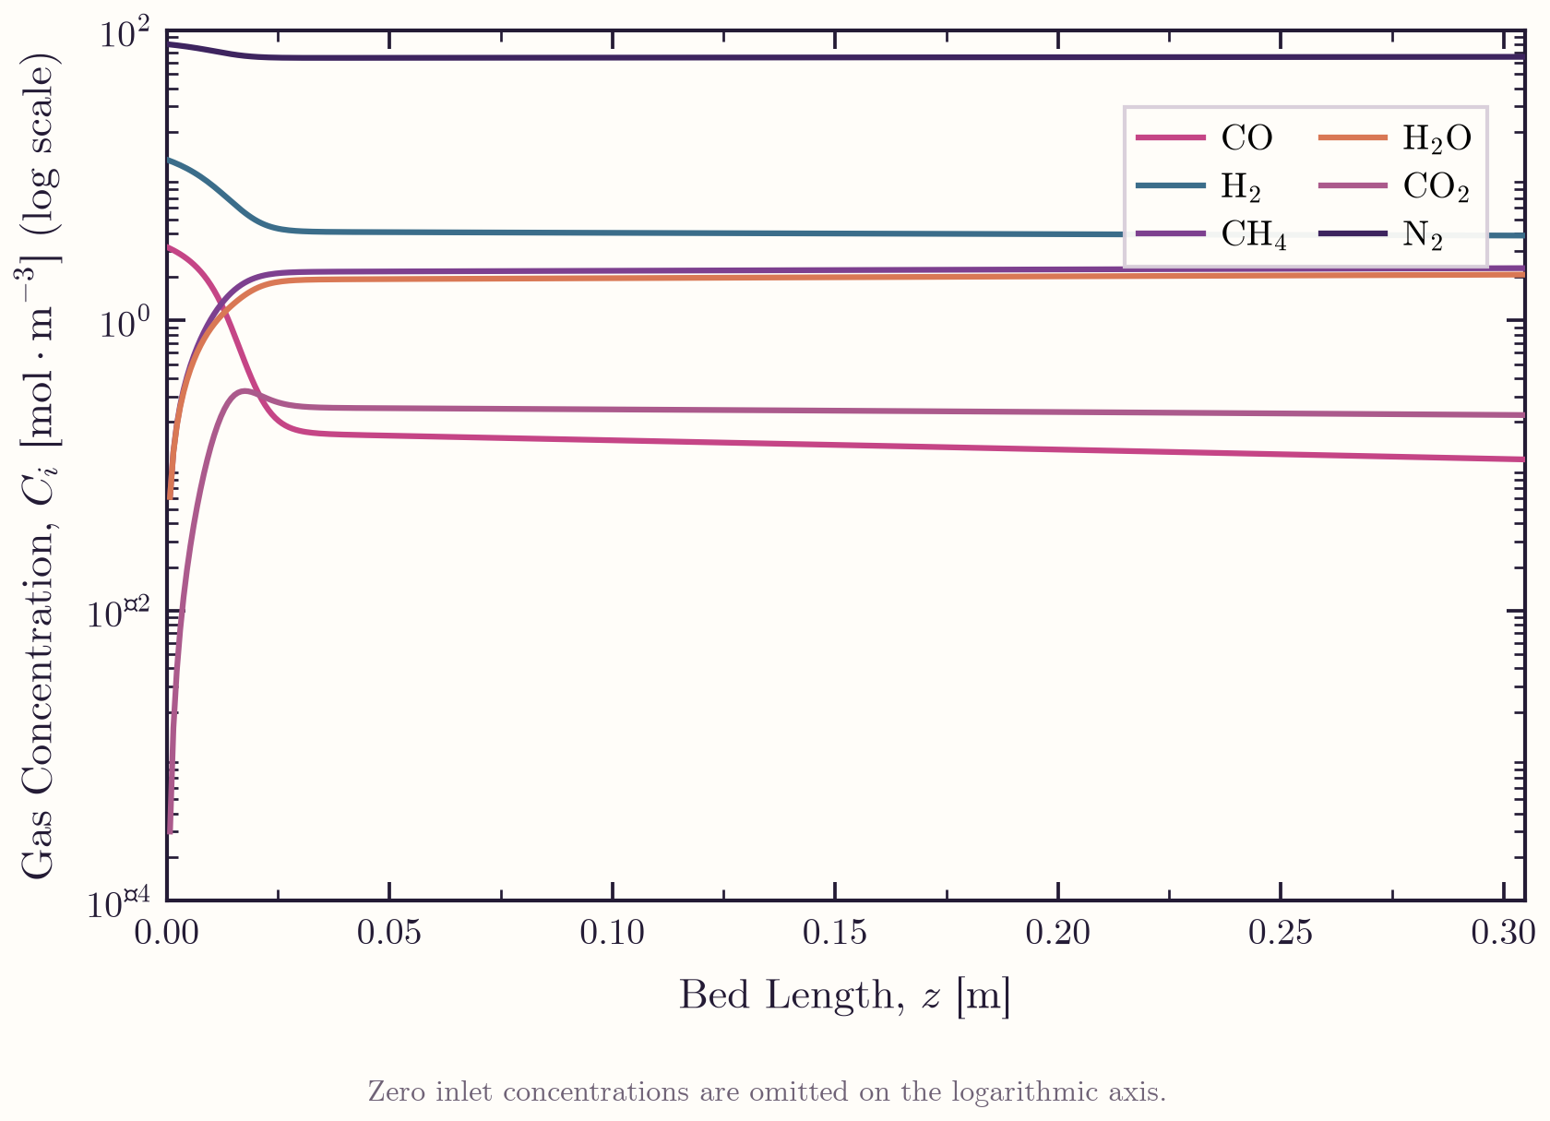
Figure 4. Full M4 species concentrations versus bed length for the assumed 5-bar, 350 $​^{∘}$C, CO:H$​_{2}$:N$​_{2}$ = 1:4:25 case.
This assumed-input profile does not use the Experiment 1 feed basis: its H$​_{2}$/CO ratio is 4 and inlet pressure is 5 bar; Experiment 1 uses H$​_{2}$/CO $=2.9969$ (about 3) and the selected 1-bar absolute basis.
PART II

Sensitivity analysis
Full M4 contour and feed-composition sweeps. Low-pressure results are conditional extrapolations below the fitted pressure domain.

CO conversion across reactor inlet conditions
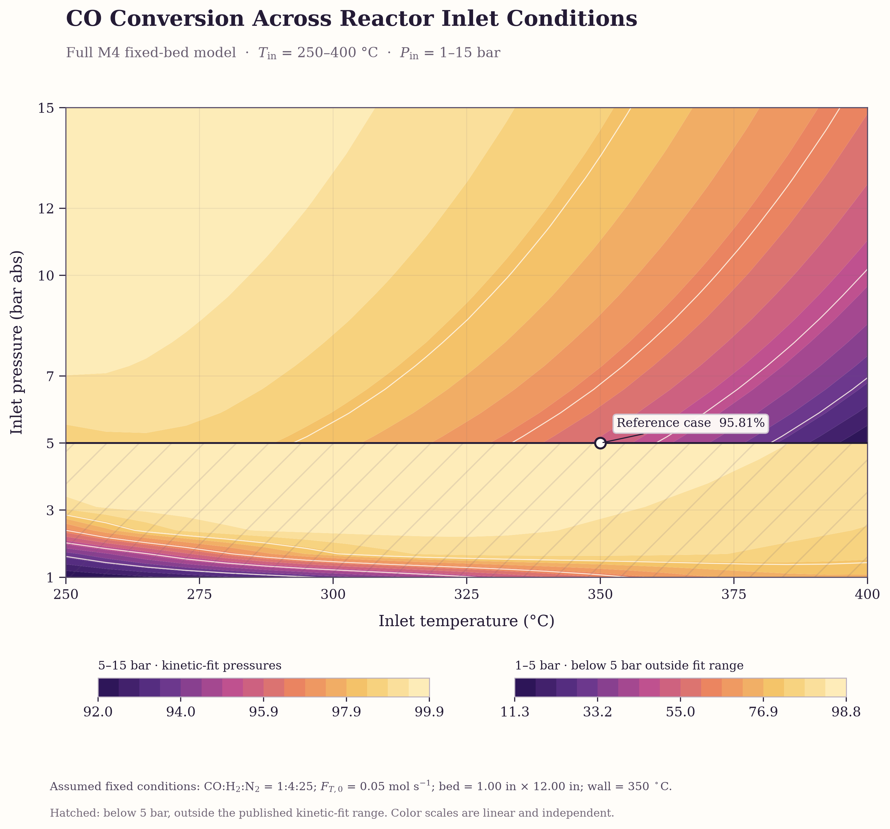
Figure 5. Full M4 sensitivity of bed-outlet CO conversion to inlet temperature and pressure.
The hatched 1–$<5 bar$ region is below the pressure range tested for the Celoria et al. kinetic fit and is an extrapolation; 5–15 bar is within the reported pressure range. The two bands use separate linear color scales, so read each colorbar independently. The sweep covers 250–400 $​^{∘}$C and varies only inlet temperature and pressure, with the other assumed base-case inputs fixed. Although inlet temperatures lie within the paper’s fitted temperature range, 469 of 484 cases have sampled bed temperatures above 400 $​^{∘}$C and therefore extrapolate the kinetics locally. This is a conditional model sensitivity, not experimental validation. Kinetic source: Celoria et al.

CO conversion within the kinetic-fit pressure range
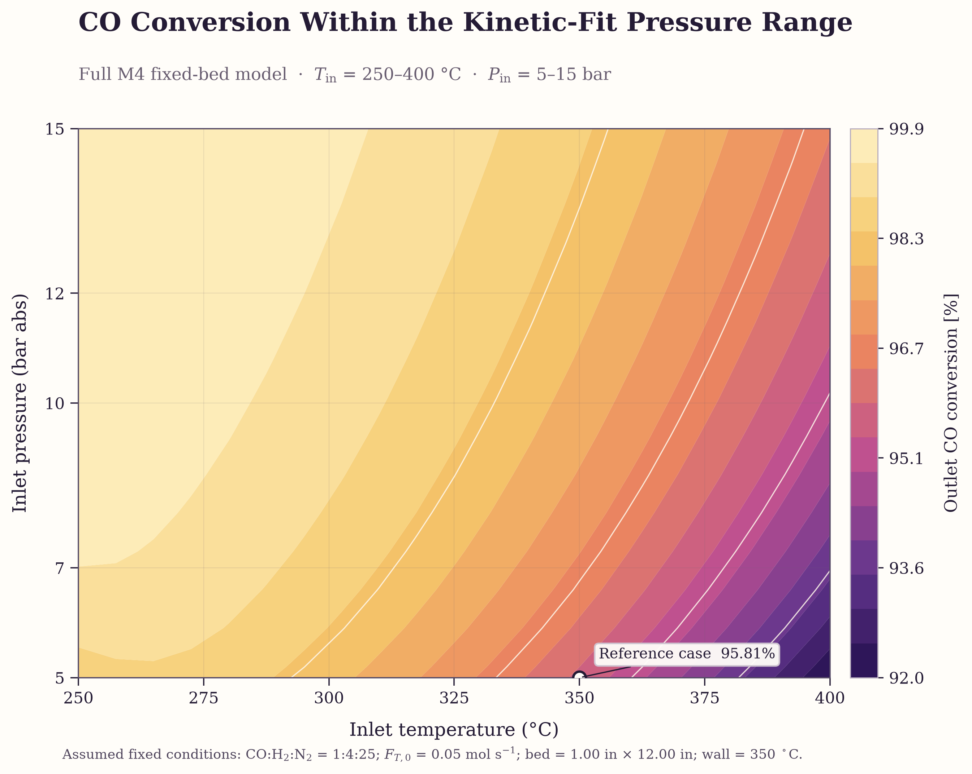
Figure 6. Full M4 sensitivity restricted to inlet pressures of 5–15 bar.
This view isolates the pressure interval reported for the Celoria et al. kinetic fit, with a single linear color scale. Inlet temperature spans 250–400 $​^{∘}$C. The kinetic fit was tested at discrete temperature and pressure conditions; values between those conditions are model interpolations. The reactor’s predicted local bed temperature may exceed 400 $​^{∘}$C even when its inlet temperature is within range, so the result remains an exploratory conditional prediction rather than experimental validation.

CO conversion across inlet ratio and catalyst space time
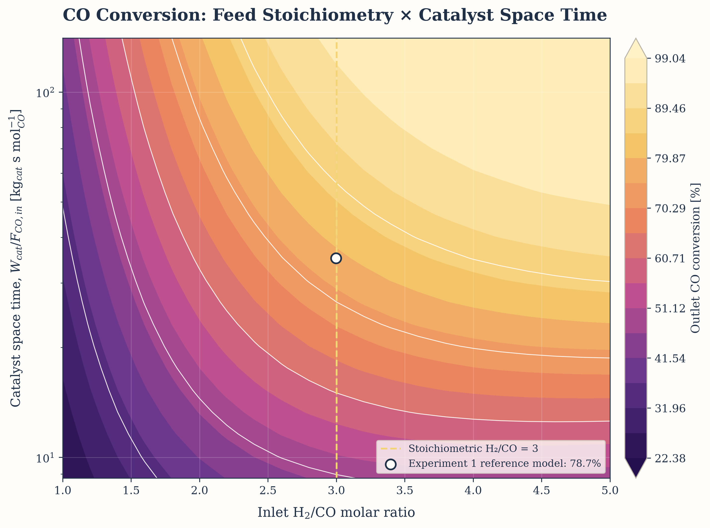
Figure 7. Full M4 predicted outlet CO conversion at 1 bar as inlet H$​_{2}$/CO ratio and catalyst space time vary.
The circle identifies the modeled Experiment 1 reference point (H$​_{2}$/CO $=2.9969$, $W_{cat}/F_{CO,in}=35.10 kg_{cat} s mol_{CO}^{−1}$), where predicted conversion is 78.72%. This differs from the source-reported 40.63%; the reported value is not used as a fit target. The sweep uses 1 bar absolute, consistent with the source’s atmospheric-pressure description; Appendix A instead lists 2 bar. The selected pressure is below the 5–15 bar kinetic-fit range.

Defining the ratio and space-time sweep
The horizontal coordinate is the inlet molar ratio
$$r_{H_{2}/CO}=\frac{F_{H_{2},in}}{F_{CO,in}},$$
where $r_{H_{2}/CO}=3$ is the stoichiometric feed ratio for CO methanation. The vertical coordinate is catalyst space time on a CO-feed basis:
$$\boxed{τ_{cat,CO}=\frac{W_{cat}}{F_{CO,in}}} [τ_{cat,CO}]=kg_{cat} s mol_{CO}^{−1}.$$
Here $W_{cat}$ is catalyst mass and $F_{CO,in}$ is inlet CO molar flow. This ratio has units of catalyst mass per CO throughput. A larger value means more catalyst is available per mole of CO fed. It is often informally called contact time, but it is not the gas residence time in seconds: gas residence time depends on bed void volume and the local volumetric flow, while $W_{cat}/F_{CO,in}$ is a catalyst-normalized throughput measure.
The sweep holds $W_{cat}=3.12 g$ fixed, so it changes space time by changing feed throughput. Equivalently,
$$F_{CO,in}=\frac{W_{cat}}{τ_{cat,CO}}, F_{H_{2},in}=r_{H_{2}/CO}F_{CO,in}, F_{N_{2},in}={\left(\frac{F_{N_{2}}}{F_{CO}}\right)}_{Exp1}F_{CO,in}.$$
Thus CO and N$​_{2}$ flows scale together and H$​_{2}$ is reset to the selected ratio; the N$​_{2}$/CO ratio remains at its Experiment 1 value. All other selected inputs are held fixed at 350 $​^{∘}$C, 1 bar absolute, and isothermal operation. The conversion plotted at each grid point is
$$X_{CO,out}(\%)=100\left(1−\frac{F_{CO,out}}{F_{CO,in}}\right).$$
The map shows the combined conditional response to stoichiometry and catalyst per CO throughput. Conversion rises strongly as the feed approaches the stoichiometric ratio from below, then the improvement diminishes at higher H$​_{2}$/CO and larger space time. These are model sensitivities, not validated operating predictions: the 1 in $×$ 12 in geometry is assumed, the 3.12 g charge implies a sparse-bed voidage of about 0.98384 under the assumed particle density, and 1 bar is below the kinetic fit’s 5 bar lower limit. The source describes atmospheric pressure in its abstract and discussion while Appendix A states 2 bar; this sweep follows the atmospheric-pressure description using a 1 bar override.

CO conversion across absolute reactive-feed flows
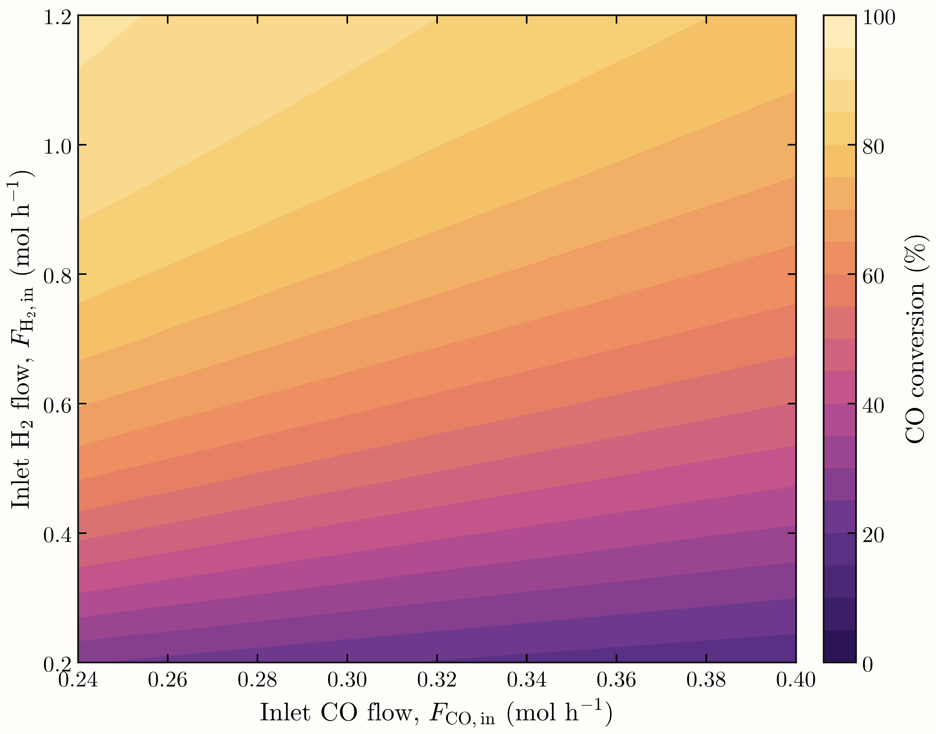
Figure 8. Full M4 predicted outlet CO conversion versus absolute inlet H$​_{2}$ and CO flow; N$​_{2}$ is fixed at $0.799 mol h^{−1}$.
Each point is a no-fit Full M4 simulation at $350 ^{∘}C$, 1.00 bar, and 3.12 g catalyst under isothermal, constant-pressure conditions. Since the axes are absolute molar flows, moving across the map changes both feed composition and total throughput; this is not solely an H$​_{2}$/CO-ratio sweep. The 1-bar condition is below the 5–15-bar kinetic-fit pressure range, so the map is an extrapolative model sensitivity rather than experimental validation. No experimental measurements are plotted.

CO conversion under nitrogen dilution
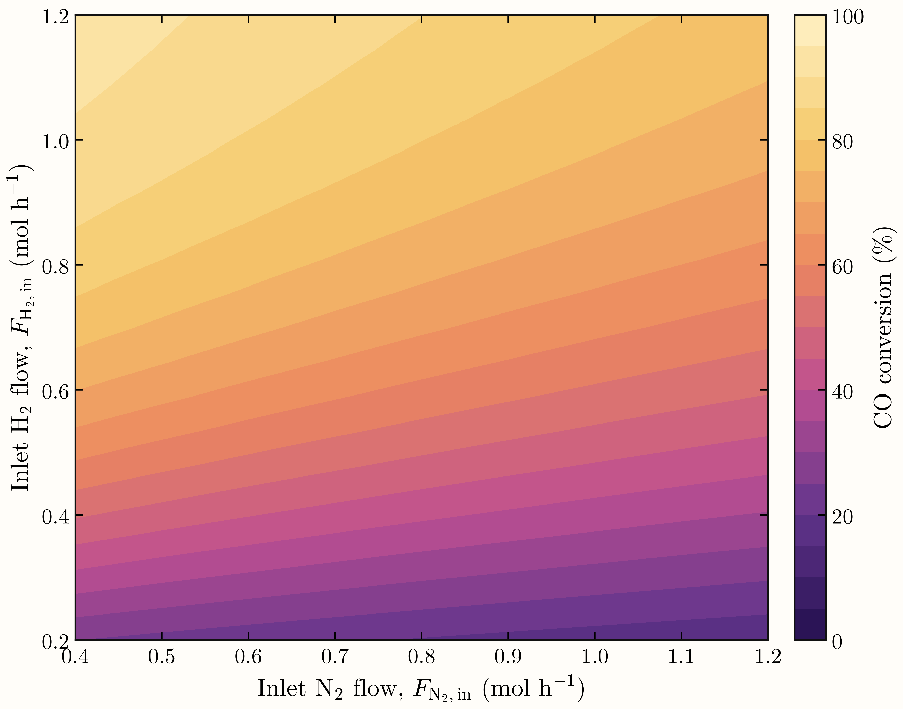
Figure 9. Full M4 predicted outlet CO conversion versus inlet H$​_{2}$ and N$​_{2}$ flow; CO is fixed at $0.320 mol h^{−1}$.
This sweep isolates the conditional effect of nitrogen dilution while varying H$​_{2}$ feed, with CO held fixed. At a given H$​_{2}$ flow, increasing the inert N$​_{2}$ feed lowers the reactant mole fractions and increases total throughput, reducing the predicted conversion. Conditions are $350 ^{∘}C$, 1.00 bar, and 3.12 g catalyst, isothermal and constant-pressure. As in Fig. 7, the 1-bar result extrapolates below the 5–15-bar kinetic-fit range and is not experimental validation; no experimental measurements are plotted.

CO conversion under nitrogen dilution
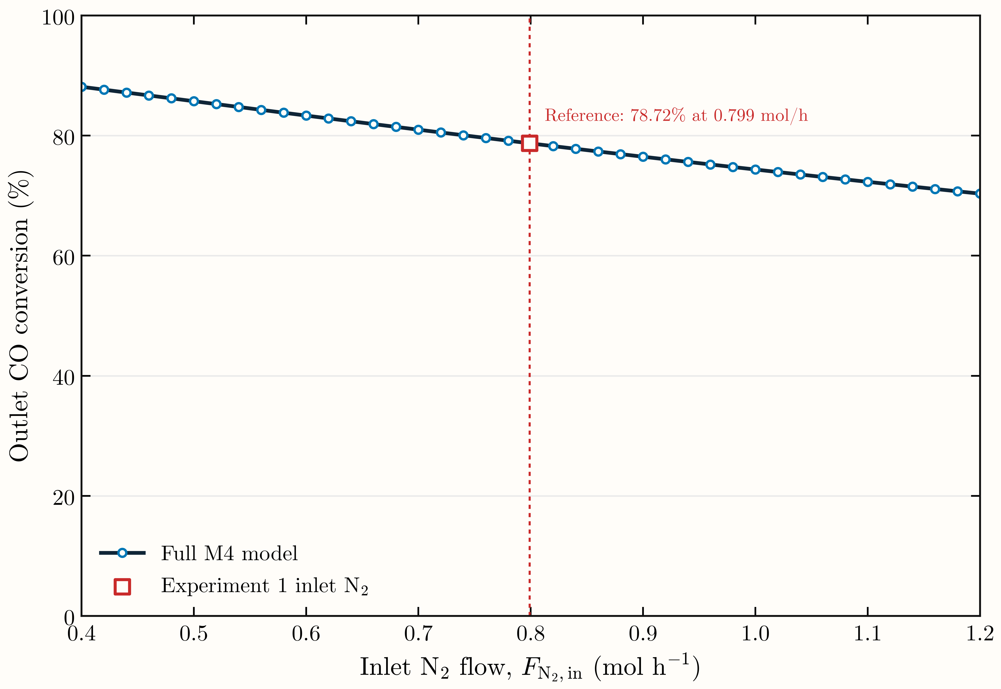
Figure 10. Full M4 predicted outlet CO conversion as inlet N$​_{2}$ flow varies from 0.4 to 1.2 mol/h, with CO = 0.320 mol/h and H$​_{2}$ = 0.959 mol/h fixed. The reference point at N$​_{2}$ = 0.799 mol/h gives 78.72% conversion. Conditions are 350 $​^{∘}$C, 1 bar absolute, and 3.12 g catalyst, isothermal and constant-pressure.
Conversion decreases from 88.14% to 70.34% over the plotted N$​_{2}$ range. The 1-bar calculations are below the 5–15-bar kinetic-fit pressure range; interpret this as a conditional model sensitivity, not experimental validation.
PART III

Optimization
A separate four-factor Full M4 grid search. The reported result is the best sampled point, not a continuous or experimentally validated optimum.

Optimization
The discrete grid search identifies the best sampled operating point for the Full M4 reactor model. It maximizes completed-bed CO conversion over four inputs: inlet H$​_{2}$/CO ratio, inlet temperature, inlet pressure, and catalyst space time on a CO-feed basis. The Experiment 1 catalyst mass (3.12 g), bed geometry and voidage, and N$​_{2}$/CO inlet ratio are fixed. At each selected H$​_{2}$/CO ratio and space time, the inlet flows are reconstructed as
$$F_{CO,in}=\frac{W_{cat}}{τ_{cat,CO}}, F_{H_{2},in}=r_{H_{2}/CO}F_{CO,in}, F_{N_{2},in}={\left(\frac{F_{N_{2}}}{F_{CO}}\right)}_{​Exp1}F_{CO,in}.$$
Thus changing space time scales the inlet throughput while preserving N$​_{2}$/CO; N$​_{2}$ is not an independent optimization variable. Each point is an isothermal Full M4 simulation with Ergun pressure drop, solved using BDF. The grid contains 12 H$​_{2}$/CO ratios, 9 inlet temperatures, 9 pressures, and 21 space-time values, for $12×9×9×21=20,412$ simulations; all completed. The objective is
$$\max_{r_{H_{2}/CO}, T_{in}, P_{in}, τ_{cat,CO}}X_{CO,out}, X_{CO,out}=100\left(1−\frac{F_{CO,out}}{F_{CO,in}}\right)\%.$$
Table 1. Best sampled point in the four-factor grid search.
Quantity | Best sampled value | Position or role
Inlet H$​_{2}$/CO ratio | 5.00 mol/mol | Upper grid bound
Inlet temperature | 370 °C | Interior grid value
Inlet pressure | 15.0 bar abs | Upper grid bound
Catalyst space time, $W_{cat}/F_{CO,in}$ | 140.4 kg_{cat}·s·mol_{CO}⁻¹ | Upper grid bound
CO / H$​_{2}$ / N$​_{2}$ inlet flows | 0.080 / 0.400 / 0.19975 mol/h | Derived values
Outlet CO conversion | 99.9999928% | Maximized objective
Outlet CH$​_{4}$ yield | 99.9999318% | Predicted output
The maximum is the best sampled grid point, not a continuous or experimentally validated optimum. The selected point lies at the upper bounds for H$​_{2}$/CO, pressure, and space time. The objective does not penalize hydrogen use, low throughput, or operating pressure, and the model is isothermal. Treat the result as exploratory; a practical operating recommendation would require those constraints and objectives to be defined.

Four-factor optimization map
The pressure-slice figure shows the conversion landscape around the selected grid point. Each panel varies inlet H$​_{2}$/CO ratio and temperature at fixed pressure, with catalyst space time held at its optimized grid value. The star marks the best sampled point at 15 bar and $370 ^{∘}C$.
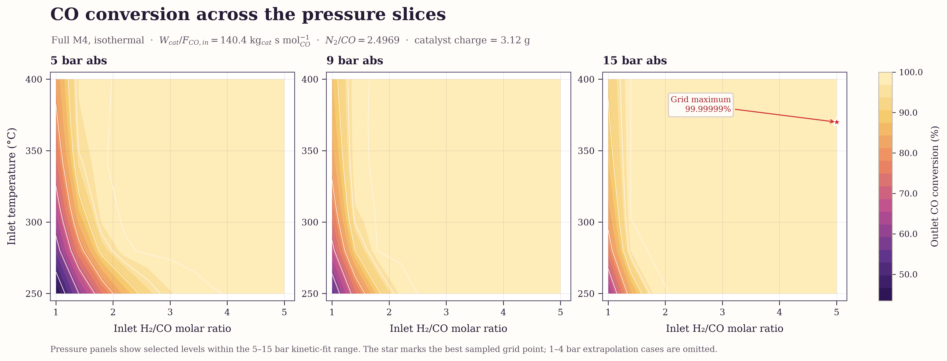
Figure 11. Pressure slices of predicted outlet CO conversion from the four-factor grid. Space time is fixed at $140.4 kg_{cat} s mol_{CO}^{−1}$; the star marks the best sampled point.
Only 5, 9, and 15 bar are shown because 1–4 bar fall below the kinetic-fit pressure range. The shared color scale allows comparison across panels. The figure and table report model predictions, not experimental validation.

